 | 
Local Insight England Summary Report  Hipperholme and Lightcliffe  Created for Calderdale CF on 5 June 2026  Oxford Consultants for Social Inclusion Ltd. All rights reserved. Copyright ©2026. This report is provided for public benefit use only and must not be used for commercial purposes. | 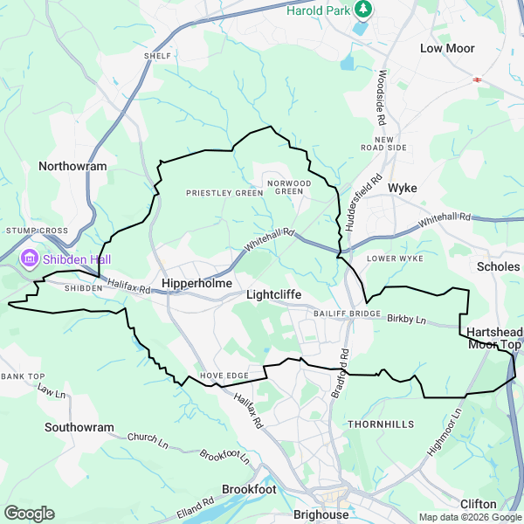

This report was generated using Local Insight by Calderdale CF
This report was generated withLocal Insight the small-area data insight platform from OCSI.
Local Insight provides instant access to the information you need for the neighbourhoods you care about. Explore up-to-date social and demographic data through intuitive maps, dashboards and reports.
You can book a demo to receive a two-week free trial, and generate your own Local Insight report:https://localinsight.org/learn-more/book-a-demo/

About OCSI
For over 20 years, OCSI has combined expertise in research and technology to support organisations working for social good to make evidence-based decisions. We have worked with more than 250 public and community sector organisations from local to international levels.
Our research and services are based on unrivalled knowledge and use of place-based social, economic and demographic data. Find out more at:ocsi.uk

About the data
OCSI keeps the platform’s data current and provides comprehensive metadata so you can be confident in the indicators you use.
Sourced from more than 50 government agencies and other reputable bodies, we identify key indicators relevant to local authorities, grantmakers and charities to include within this report and the Local Insight platform.
Subscribers can get in touch to discuss designing bespoke report themes with a member of the OCSI team:localinsight.org/bespoke-report-theme-interest/

How we have identified the area of Hipperholme and Lightcliffe
This report is based on the “Hipperholme and Lightcliffe” area, created by Calderdale CF. The map image of the area is shown at the beginning of this report. The map imagery is provided by Google, using boundary definitions published by the Office for National Statistics (ONS). Statistical and geographic data are sourced from the ONS and are used under the terms of the Open Government Licence v3.0. Contains Ordnance Survey data © Crown copyright and database right [2026].
Local Insight draws on data from a range of official sources. Where values are not available directly for the geographies used in this report, they are calculated using an ONS-aligned statistical aggregation and apportioning methodology
Alongside data for the “Hipperholme and Lightcliffe” area, we also display data for the selected comparator areas: Calderdale and Yorkshire and The Humber.

At a glance
A quick overview of key data in this Local Insight report for Hipperholme and Lightcliffe and how it compares to Calderdale and Yorkshire and The Humber.
   | Population  There are 11,727 people living in Hipperholme and Lightcliffe  This is smaller than the population of Calderdale (210,929) and smaller than the population of Yorkshire and The Humber (5,672,962)
   | Unemployment  2.19% of people in Hipperholme and Lightcliffe are receiving unemployment benefits  This is lower than the average across Calderdale (4.26%) and lower than the average across Yorkshire and The Humber (4.16%)
   | Housing  The average property price in Hipperholme and Lightcliffe is £270,699  This is higher than within Calderdale (£218,554) and higher than the average within Yorkshire and The Humber (£238,756)
   | Crime  There were 791 total crime offences in Hipperholme and Lightcliffe between Mar-2025 to Feb-2026  This is lower than the average across Calderdale (120.4) and lower than the average across Yorkshire and The Humber (109.0)
   | Health  8.31% of the working-age population in Hipperholme and Lightcliffe are receiving Personal Independence Payments (PIP)  This is lower than the proportion in Calderdale (12.04%) and lower than the proportion in Yorkshire and The Humber (11.6%)
   | Education  15.01% of people aged 16+ in Hipperholme and Lightcliffe have no qualifications  This is lower than the average in Calderdale (19.18%) and lower than the average in Yorkshire and The Humber (20.62%)
   | Communities and Environment  Hipperholme and Lightcliffe has an overall Community Needs Index rank of 26,632  This means that Hipperholme and Lightcliffe has lower levels of community need than Calderdale (20,620) and lower levels of community need than Yorkshire and The Humber (15,002)
   | Access and Transport  Hipperholme and Lightcliffe has an overall Connectivity Score of 63.84  This means that Hipperholme and Lightcliffe has higher levels of connectivity than Calderdale (62.45) and higher levels of connectivity than Yorkshire and The Humber (62.73)

Contents
Population
Unemployment
Housing
Crime
Health
Education
Employment
Communities and Environment
Access and Transport
Appendix: Data sources

Population
Population Composition

The table below provides insight into the population composition in Hipperholme and Lightcliffe. These population figures provide detail of the structure of the population by broad age bands and sex. This data is taken from the Office for National Statistics (ONS) 2024 Mid-Year Population Estimates.
There are 11,727 people in Hipperholme and Lightcliffe. This is smaller than the population of Calderdale (210,929) and smaller than the population of Yorkshire and The Humber (5,672,962).

Population Composition
Indicator | Hipperholme and Lightcliffe |  | Calderdale |  | Yorkshire and The Humber
 | Count | Rate | Count | Rate | Count | Rate
Total | 11,727 | - | 210,929 | - | 5,672,962 | -
Male | 5,668 | 48.33% | 103,428 | 49.03% | 2,786,941 | 49.13%
Female | 6,059 | 51.67% | 107,501 | 50.97% | 2,886,021 | 50.87%
0 to 15 | 1,989 | 16.96% | 39,748 | 18.84% | 1,044,066 | 18.40%
16 to 64 | 7,080 | 60.37% | 129,891 | 61.58% | 3,533,340 | 62.28%
65 and over | 2,658 | 22.67% | 41,290 | 19.58% | 1,095,556 | 19.31%
Source: Office for National Statistics (ONS)

The Index of Multiple Deprivation (IMD)

The Index of Multiple Deprivation 2025 (IMD 2025) combines information from the seven domains to produce an overall relative measure of deprivation.The boxes below show the IMD score and rank for Hipperholme and Lightcliffe, Calderdale, Yorkshire and The Humber (average LSOA Score/Rank, where a higher score and a lower rank indicate that an area is experiencing higher levels of deprivation). In order to maintain consistency with the LSOA level convention, Rank 1 = most deprived for the average-LSOA rank measures. This differs from the published average rank figures for higher level geographies.
Hipperholme and Lightcliffe has an IMD rank of 23,304. This means that Hipperholme and Lightcliffe has lower levels of deprivation compared to Calderdale (13,431) and lower levels of deprivation compared to Yorkshire and The Humber (14,987).

  IMD 2025 Score
  12.61
  (Calderdale = 27.58, Yorkshire and The Humber = 25.98)
  IMD 2025 Rank
  23,304
  (Calderdale = 13,431, Yorkshire and The Humber = 14,987)
Source: Ministry of Housing Communities and Local Government (MHCLG; 2025)

The bar chart below explores this further, showing the proportion of people living in neighbourhoods grouped into deciles according to level of deprivation derived from the IMD. To clarify, all neighbourhoods in England are grouped into ten equal sized groups referred to as “deciles.” Neighbourhoods in Decile 1 fall within the most deprived 10% of neighbourhoods nationally, whilst neighbourhoods in Decile 10 fall within the least deprived 10% of neighbourhoods nationally.

0.00% of people in Hipperholme and Lightcliffe are living in neighbourhoods ranked within the most deprived 10% of neighbourhoods nationally on the IMD.

Deprivation Deciles
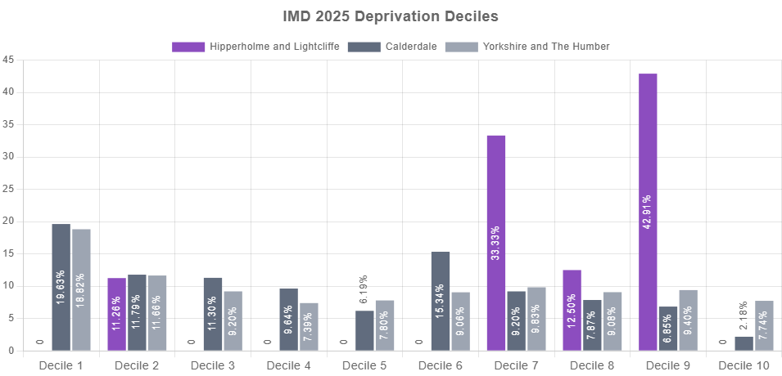
Source: Ministry of Housing Communities and Local Government (MHCLG; 2025)

Unemployment
The table below shows the total number and proportion of people receiving Universal Credit (UC) or Job Seekers Allowance (JSA) by age and sex.
The proportion of working age people receiving benefits for unemployment in Hipperholme and Lightcliffe was 2.19% in Apr-2026. This is lower than the average across Calderdale (4.26%) and lower than the average across Yorkshire and The Humber (4.16%).

Unemployment Benefit Claimants
Indicator | Hipperholme and Lightcliffe |  | Calderdale |  | Yorkshire and The Humber
 | Count | Rate | Count | Rate | Count | Rate
Unemployment benefit claimants (Jobseekers Allowance and out of work Universal Credit claimants) | 155 | 2.19% | 5,535 | 4.26% | 146,935 | 4.16%
Youth unemployment (18-24 receiving JSA or Universal Credit) | 40 | 5.06% | 1,270 | 8.60% | 32,270 | 6.45%
Older person unemployment (50+ receiving JSA or Universal Credit) | 35 | 0.67% | 1,140 | 1.33% | 29,540 | 1.35%
Unemployment benefit (JSA and Universal Credit), female | 65 | 1.76% | 2,290 | 3.48% | 62,100 | 3.48%
Unemployment benefit (JSA and Universal Credit), male | 90 | 2.65% | 3,250 | 5.08% | 84,835 | 4.86%
Source: Department for Work and Pensions (DWP)

The chart below shows the total proportion of people receiving unemployment benefit (JSA or Universal Credit) between Jan-2020 and Apr-2026.
The total unemployment rate in Hipperholme and Lightcliffe has increased from 1.81% in Jan-2020 to 2.19% in Apr-2026.

Unemployment Benefit Claimants (time series)
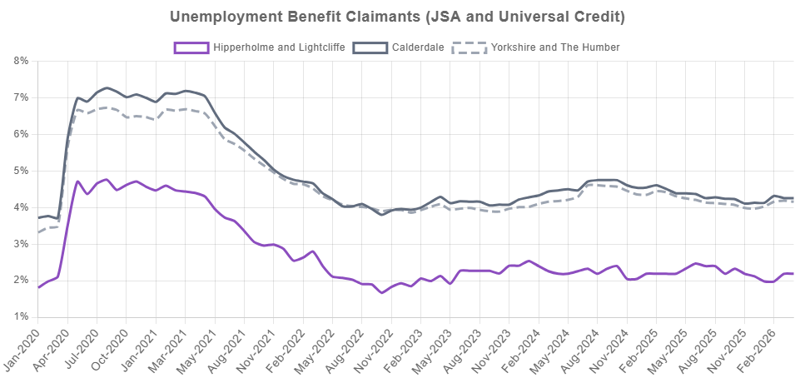
Source: Department for Work and Pensions (DWP)

Housing
Average House Prices

The figures below show the mean house prices by accommodation type across Hipperholme and Lightcliffe and comparator areas for four key dwelling types (detached houses, semi-detached houses, terraced houses and flats). Data on house prices is from theLand Registry open data, price-paid dataset The Land Registry collect data on all housing transactions, published by individual property and date with the average house-price for all property types calculated on a rolling 12 months total.
The average property price for all dwelling types in Hipperholme and Lightcliffe was £270,699 between Mar-2025 to Feb-2026. This is higher than within Calderdale (£218,554) and higher than the average within Yorkshire and The Humber (£238,756).
Note: Some small areas may not have had a transaction recorded within the twelve month period leading to gaps in the figures below.

Average House Price
£270,699
(Calderdale = £218,554, Yorkshire and The Humber = £238,756)

Source: UK Land Registry (Mar-2025 to Feb-2026)

Average House Prices
Indicator | Hipperholme and Lightcliffe | Calderdale | Yorkshire and The Humber
Detached Houses | £459,026 | £424,754 | £388,298
Semi-Detached Houses | £255,592 | £240,113 | £226,987
Terraced Houses | £214,139 | £167,175 | £172,717
Flats | £124,278 | £148,988 | £156,173
Source: UK Land Registry

Housing Tenure

The chart below provides the proportion of the housing in the area by tenure type. The tenure of a household is derived from the response to the 2021 Census question asking whether the household owns or rents its accommodation and, if rented, from the response to the question asking who is the landlord.

Housing Tenure
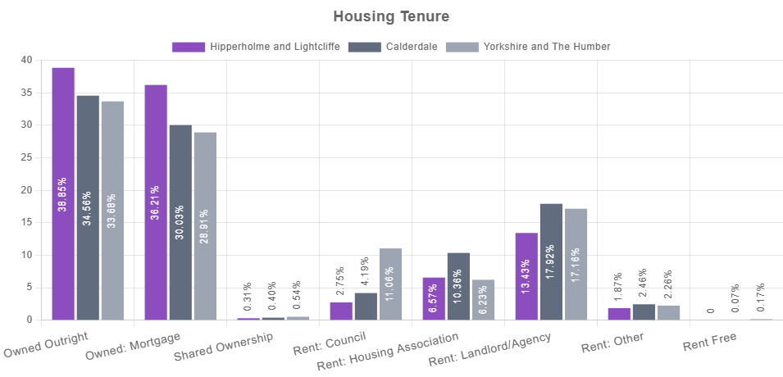
Source: Census 2021

Crime
The following data provides insight into the recorded crime rates in an area. The data is created using the rolling 12 month total of neighbourhood-level incidents for various types of offence as a rate per 1,000 residents. The incidents were located to the point at which they occurred and allocated to the appropriate lower super output area (LSOA). This is based on data for individual crime incidents published via thePolice UK open data portal which has been linked by Local Insight to selected neighbourhoods.
Please note there can be missing data in Police.uk crime counts for certain areas. This is often due to issues with IT system changes at various police forces which affects their reporting of figures to Police UK. Please seePolice UK's change log for details of current known issues.

Crime and Anti-Social Behaviour Summary

The table below shows counts and rates for the main crime types and anti-social behaviour incidents between Mar-2025 to Feb-2026.
There were 791 total crime offences in Hipperholme and Lightcliffe between Mar-2025 to Feb-2026, with the overall crime rate being 67.4 per 1,000 population. This is lower than the average across Calderdale (120.4) and lower than the average across Yorkshire and The Humber (109.0).

Crime and Anti-Social Behaviour Summary
Indicator | Hipperholme and Lightcliffe |  | Calderdale |  | Yorkshire and The Humber
 | Count | Rate | Count | Rate | Count | Rate
Total Crime | 791 | 67.4 | 25,389 | 120.4 | 618,280 | 109.0
Anti-Social Behaviour | 111 | 9.5 | 2,921 | 13.8 | 78,306 | 13.8
Bicycle Theft | 2 | 0.2 | 79 | 0.4 | 4,392 | 0.8
Burglary | 39 | 7.7 | 1,158 | 12.8 | 27,962 | 12.0
Criminal Damage | 51 | 4.4 | 1,839 | 8.7 | 47,133 | 8.3
Drug Crime | 11 | 0.9 | 954 | 4.5 | 19,682 | 3.5
Other Crime | 25 | 2.1 | 841 | 4.0 | 18,330 | 3.2
Other Theft | 45 | 3.8 | 1,475 | 7.0 | 36,437 | 6.4
Shoplifting | 86 | 7.3 | 1,437 | 6.8 | 48,034 | 8.5
Possession of Weapons | 4 | 0.3 | 185 | 0.9 | 5,862 | 1.0
Public Order | 57 | 4.9 | 2,282 | 10.8 | 48,409 | 8.5
Robbery | 6 | 0.5 | 228 | 1.1 | 6,987 | 1.2
Theft From Person | 3 | 0.3 | 128 | 0.6 | 3,666 | 0.6
Vehicle Crime | 68 | 5.8 | 1,089 | 5.2 | 30,844 | 5.4
Violent Crime & Sexual Offences | 283 | 24.1 | 10,773 | 51.1 | 242,236 | 42.7
Source: Police UK

Total Crime Rate

The line chart below shows a time series made up of 12-month totals of neighbourhood-level incidents of criminal offences. The figure is a rate per 1,000 residents. The first data point covers Sep-2018 to Aug-2019 and the final data point covers Mar-2025 to Feb-2026.
The overall crime rate in Hipperholme and Lightcliffe has decreased from 75.0 per 1,000 people between Sep-2018 to Aug-2019 to 67.4 per 1,000 people between Mar-2025 to Feb-2026.

Total Crime Rate
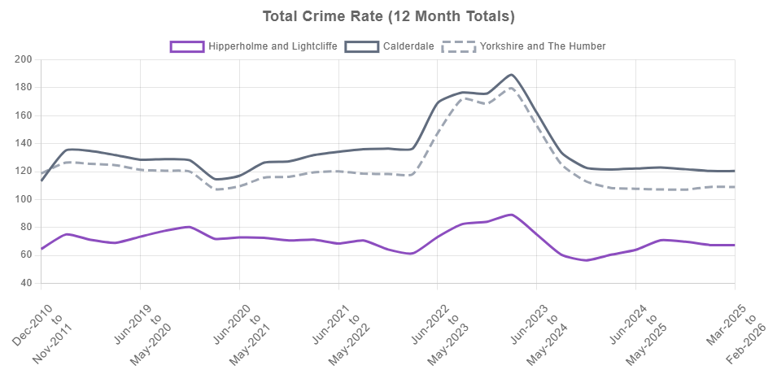
Source: Police UK

Health
Disability Benefits

The table below shows a series of indicators related to disability benefits providing the total numbers of claims and proportions within each area that are accessing the support systems available. It includes the following benefits;
- Personal Independence Payment (PIP) can help with extra living costs if you have both: a long-term physical or mental health condition or disability and difficulty doing certain everyday tasks or getting around because of your condition.
- Disability Living Allowance (DLA) is payable to children and adults who become disabled before the age of 65. It is being replaced by other benefits (mainly PIP).
- Attendance Allowance helps with extra costs if you are over 65 and have a disability severe enough that you need someone to help look after you.
- Universal Credit (UC) disabled child entitlement is an increased award for the child element of UC where a child is entitled to a rate of DLA or PIP.
- Universal Credit (UC) limited capability to work entitlement is for when a household member has limited capacity to work due to poor mental or physical health conditions.

8.31% of the working-age population in Hipperholme and Lightcliffe are receiving Personal Independence Payments (PIP). This is lower than the proportion in Calderdale (12.04%) and lower than the proportion in Yorkshire and The Humber (11.6%).

Disability Benefits
Indicator | Hipperholme and Lightcliffe |  | Calderdale |  | Yorkshire and The Humber
 | Count | Rate | Count | Rate | Count | Rate
Personal Independence Payment (PIP) | 588 | 8.31% | 15,644 | 12.04% | 409,749 | 11.60%
Disability benefit (DLA) | 208 | 1.77% | 5,335 | 2.53% | 134,644 | 2.37%
Older people social care benefit (Attendance Allowance) | 315 | 11.86% | 5,624 | 13.62% | 159,850 | 14.59%
Households on Universal Credit, Disabled Child Entitlement | 79 | 1.55% | 2,364 | 2.61% | 55,606 | 2.39%
Households on Universal Credit - Limited Capability for Work Entitlement | 306 | 6.02% | 10,963 | 12.12% | 267,888 | 11.49%
Source: Department for Work and Pensions (DWP)

Long-Term Physical/Mental Health Conditions

The boxes below show the number and proportion of people disabled under the Equality Act with different limitations on day-to-day activity and also for those who have a long term physical or mental health condition but are not limited day to day.
Figures are taken from responses to the 2021 Census and are based on a self assessment of whether or not a person has a limiting long-term illness, health problem or disability which limits their daily activities or the work they can do, including problems that are due to old age.
In Hipperholme and Lightcliffe, the proportion of people disabled under the Equality Act with their day-to-day activities limited a lot is 6.11%. This is lower than the proportion in Calderdale (7.95%) and lower than the proportion in Yorkshire and The Humber (8.1%).

  Day-to-Day Activities Limited a Lot
  712
  6.11% (Calderdale = 7.95%, Yorkshire and The Humber = 8.1%)
  Day-to-Day Activities Limited a Little
  1,106
  9.49% (Calderdale = 10.38%, Yorkshire and The Humber = 10.53%)
  Physical or Mental Health Condition but Day-to-Day Activities Are Not Limited
  938
  8.05% (Calderdale = 7.22%, Yorkshire and The Humber = 6.92%)
Source: Census 2021

Self-Reported General Health

The chart below shows data from Census 2021 on the proportion of residents within each response category from a self-assessment of general health.
0.95% of people in Hipperholme and Lightcliffe have very bad health. This is lower than the proportion in Calderdale (1.3%) and lower than the proportion in Yorkshire and The Humber (1.32%).

Self-Reported General Health
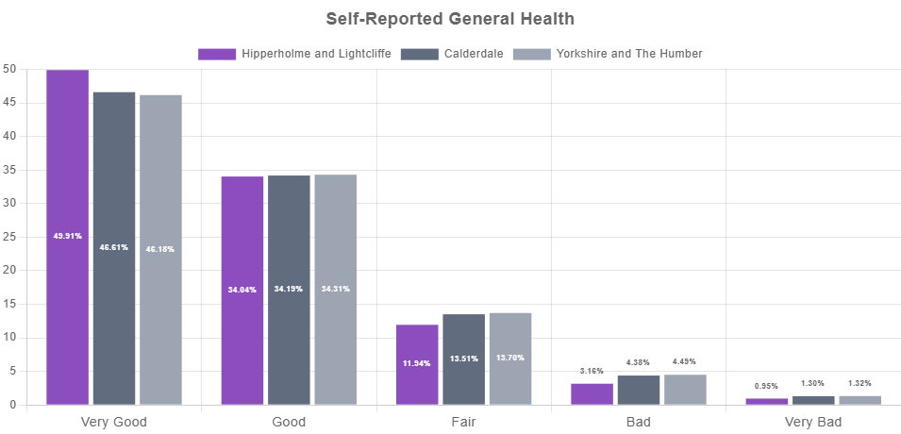
Source: Census 2021

Education
Level of Qualification

The visualisations below shows the composition of people aged 16+ by level of qualification. Data is taken from the 2021 Census.
There are 564 people in Hipperholme and Lightcliffe with an apprenticeship as their highest qualification, 5.93% of all people aged over 16. This is similar to the average for Calderdale (6.32%) and similar to the average for Yorkshire and The Humber (6.14%).

Level of Qualification
Indicator | Hipperholme and Lightcliffe |  | Calderdale |  | Yorkshire and The Humber
 | Count | Rate | Count | Rate | Count | Rate
No Qualifications | 1,428 | 15.01% | 31,965 | 19.18% | 919,640 | 20.62%
Level 1 | 881 | 9.26% | 16,313 | 9.79% | 449,065 | 10.07%
Level 2 | 1,293 | 13.59% | 23,351 | 14.01% | 607,396 | 13.62%
Apprenticeship | 564 | 5.93% | 10,524 | 6.32% | 273,719 | 6.14%
Level 3 | 1,767 | 18.57% | 29,096 | 17.46% | 777,070 | 17.42%
Level 4+ | 3,383 | 35.56% | 51,419 | 30.86% | 1,315,456 | 29.49%
Other | 198 | 2.08% | 3,966 | 2.38% | 117,953 | 2.64%
Source: Census 2021

No Qualifications Over Time

The bar chart below is a visualisation of the change in the proportion of people with no qualifications over a 10 year period by comparing data from Census 2011 to Census 2021.

No Qualifications (2011 vs. 2021)
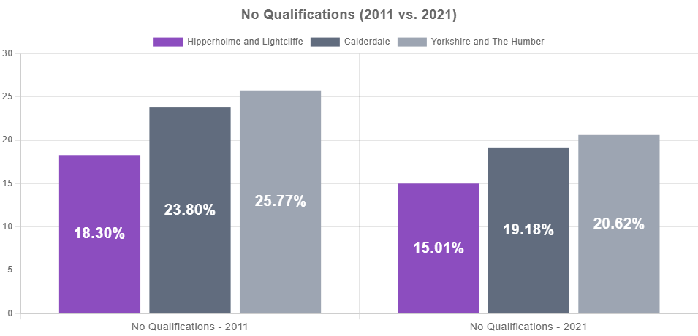
Source: Census 2021

Employment
Full-Time and Part-Time Jobs

The chart below shows the number (rounded to the nearest 1,000) and proportion of all employee jobs that are full-time and part-time. Data is taken from the 2024 Business Register and Employment Survey (BRES) of approximately 80,000 businesses and weighted to represent all sectors of the UK economy.
There are approximately 1,500 full-time jobs and 800 part-time jobs in Hipperholme and Lightcliffe. The proportion of full-time jobs in Hipperholme and Lightcliffe (66.67%) is lower than the proportion in Calderdale (67.78%) and lower than the proportion in Yorkshire and The Humber (68.15%).

Full-Time and Part-Time Jobs
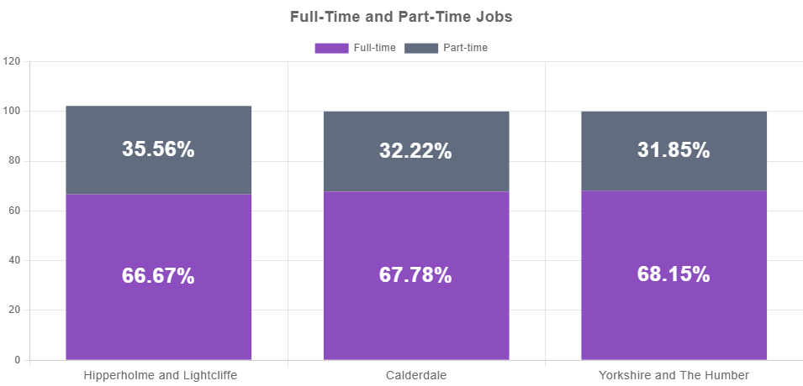
Source: Business Register and Employment Survey (BRES)

Jobs Density

The chart below shows a time series of job density between 2011 and 2024 across Hipperholme and Lightcliffe, Calderdale, Yorkshire and The Humber. Jobs density reflects the number of jobs located in the local area as a percentage of the working age population in that area. Data is taken from the Business Register and Employment Survey (BRES) of approximately 80,000 businesses and weighted to represent all sectors of the UK economy.
In Hipperholme and Lightcliffe, the jobs density has decreased, from 41.06 in 2011 to 35.31 in 2024. This latest figure is lower than the ratio in Calderdale (70.83) and lower than the ratio in Yorkshire and The Humber (72.71).
The BRES definition of an employee is anyone working on the BRES reference date who is aged 16 years or over that the contributor directly pays from its payroll(s), in return for carrying out a full-time or part-time job or being on a training scheme.

Jobs Density
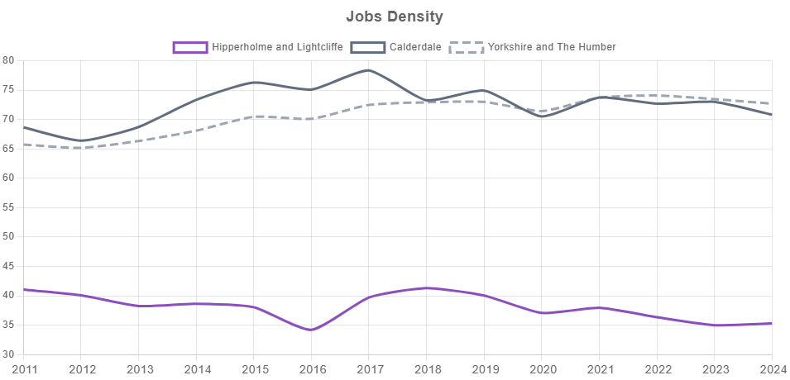
Source: Business Register and Employment Survey (BRES)

Communities and Environment
Community Needs Index (CNI) Ranks

The chart below shows the overall rank on the 2023 Community Needs Index (CNI), as well as a rank on each of the three CNI domains for Hipperholme and Lightcliffe, Calderdale, Yorkshire and The Humber. The CNI was developed to identify areas experiencing poor community and civic infrastructure, relative isolation and low levels of participation in community life. The index was created by combining a series of 28 indicators, conceptualised under three domains: Civic Assets, Connectedness and Active and Engaged Community. A lower rank indicates that an area has relatively higher levels of need.
- Civic Assets: measures the presence of key community, civic, educational and cultural assets in a close proximity of the area. These include pubs, libraries, green space, community centres, swimming pools – facilities that provide things to do often, at no or little cost, which are important to how positive a community feels about its area.
- Connectedness: measures the connectivity to key services, digital infrastructure, isolation and strength of the local jobs market. It looks at whether residents have access to key services, such as health services, within a reasonable travel distance. It considers how good public transport and digital infrastructure are and how strong the local job market is.
- Active and Engaged Community: measures the levels of third sector civic and community activity and barriers to participation and engagement. It shows whether charities are active in the area, and whether people appear to be engaged in the broader civic life of their community.

Hipperholme and Lightcliffe has an overall CNI rank of 26,632. This means that Hipperholme and Lightcliffe has lower levels of community need than Calderdale (20,620) and lower levels of community need than Yorkshire and The Humber (15,002).

CNI Rank
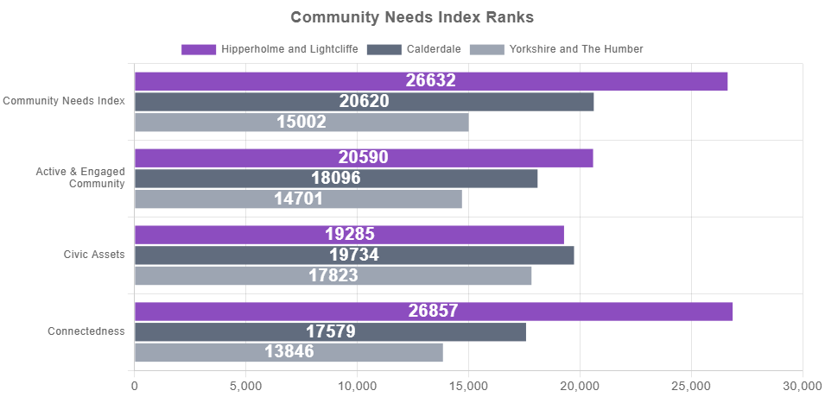
Source: Oxford Consultants for Social Inclusion (OCSI)

Indices of Deprivation (IoD) Air Quality

The boxes below show modelled estimates of air quality based on the concentration of four pollutants: Nitrogen Dioxide, Benzene, Sulphur Dioxide and Particulates. Values for each of the pollutants were based on 2023 air quality data published by the UK Air Information Resource for 1km grid-squares. A higher concentration indicates that an area is experiencing higher levels of deprivation.
Hipperholme and Lightcliffe's estimated concentration of Nitrogen Dioxide is 1.10. This is higher than the concentration in Calderdale (0.89) and higher than the concentration in Yorkshire and The Humber (0.97).

  Nitrogen Dioxide
  1.10
  (Calderdale = 0.89, Yorkshire and The Humber = 0.97)
  Benzene
  0.10
  (Calderdale = 0.08, Yorkshire and The Humber = 0.08)
  Sulphur Dioxide
  0.06
  (Calderdale = 0.05, Yorkshire and The Humber = 0.04)
  Particulates
  1.39
  (Calderdale = 1.31, Yorkshire and The Humber = 1.36)
Source: Ministry of Housing Communities and Local Government (MHCLG; 2025)

Funding

The boxes below look at data on community funding, showing a rolling 12 month total combined grant funding per 10,000 of population from ALL grant giving organisation types, this includes: Central Government, Local Governments, Devolved Governments, Lottery Distributors, and Grantmaking Organisations. This is followed by the more granular indicators of the non-government grant giving organisation types (Lottery Distributors, and Grantmaking Organisations).
The total amount awarded from ALL grant giving organisation types per 10,000 of population from Mar-2025 to Feb-2026 in Hipperholme and Lightcliffe is £0. This is lower than the amount of funding per 10,000 of population across Calderdale (£1,264,036) and lower than the amount of funding per 10,000 of population across Yorkshire and The Humber (£337,545).

Total amount awarded from all grant giving organisation types per 10,000 of population (12 month total)
£0
(Calderdale = £1,264,036, Yorkshire and The Humber = £337,545)

Source: 360Giving (Mar-2025 to Feb-2026)

  Total amount awarded from Lottery Distributors per 10,000 of population (12 month total)
  £0
  (Calderdale = £208,128, Yorkshire and The Humber = £62,388)
  Total amount awarded from Grantmaking Organisations per 10,000 of population (12 month total)
  £0
  (Calderdale = £208,128, Yorkshire and The Humber = £62,388)
Source: 360Giving (Mar-2025 to Feb-2026)

Access and Transport
Car Ownership

The table below shows the number and proportion of households according to their ownership of a car or van. This is based on responses to the car ownership question in the 2021 Census which asks information on the number of cars or vans owned, or are available for use, by one or more members of a household. This includes company cars and vans available for private use and is based on details for private households only. Cars or vans used by residents of communal establishments are not counted.
In Hipperholme and Lightcliffe, 14.52% of households have no access to a car or van. This is less than the proportion without access to a car or van in Calderdale (24.51%) and less than the proportion without access to a car or van in Yorkshire and The Humber (24.24%).

Car or Van Ownership
Indicator | Hipperholme and Lightcliffe |  | Calderdale |  | Yorkshire and The Humber
 | Count | Rate | Count | Rate | Count | Rate
No Car | 738 | 14.52% | 22,177 | 24.51% | 564,965 | 24.24%
1 Car | 2,162 | 42.53% | 38,826 | 42.91% | 980,137 | 42.05%
2 Cars | 1,653 | 32.51% | 22,646 | 25.03% | 600,010 | 25.74%
3+ Cars | 531 | 10.44% | 6,827 | 7.55% | 185,548 | 7.96%
Source: Census 2021

The bar chart below shows the numbers of households with no car or van in the 2021 Census alongside the proportions from the previous Census to identify changes over time.
In 2011, 16.83% of households in Hipperholme and Lightcliffe had no access to a car or van. This is greater than the proportion without access to a car or van in 2021 (14.52%).

Households With No Car or Van (2011 vs. 2021)
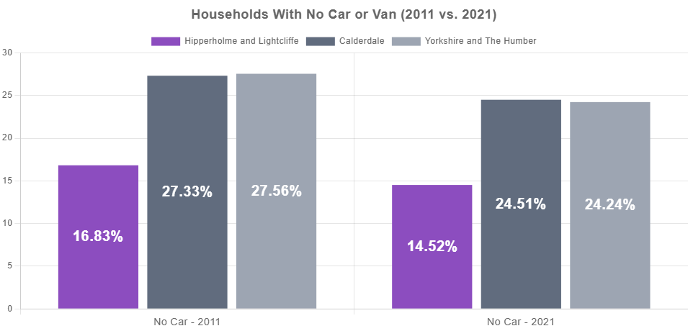
Source: UK Census

Connectivity

The visualisations below show the Overall Department for Transport (DfT) Connectivity Score for all destination types. Connectivity scores represent ease of access to services and range from 0 to 100, where a higher score represents higher levels of connectivity. It is calculated using journey planning algorithms considering actual transport networks and service timetables, the total value of all destinations within reach, and the propensity to travel to each destination type by each transport mode at different times of day.
Note: Connectivity Trips that start in England and Wales and end in Scotland are included, meaning that destinations in Scotland can contribute to connectivity in locations outside of Scotland. A cut-off point has been set for a maximum travel time of 60 minutes to limit the number of calculations.
Hipperholme and Lightcliffe has an overall Connectivity Score of 63.84. This means that Hipperholme and Lightcliffe has higher levels of connectivity than Calderdale (62.45) and higher levels of connectivity than Yorkshire and The Humber (62.73).

Overall Connectivity Score
63.84
(Calderdale = 62.45, Yorkshire and The Humber = 62.73)

Source: Department for Transport (DfT; 2025)

Overall Connectivity by Destination Type
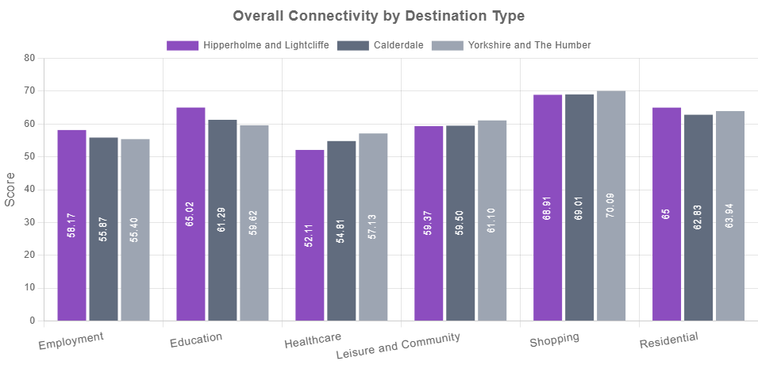
Source: Department for Transport (DfT; 2025)

Appendix: Data sources

Theme | Data | Data source / time period
Population | Total population estimate | Office for National Statistics (ONS) (2024)
Population | Male population | Office for National Statistics (ONS) (2024)
Population | Female population | Office for National Statistics (ONS) (2024)
Population | Population aged 0 to 15 | Office for National Statistics (ONS) (2024)
Population | Population aged 16 to 64 | Office for National Statistics (ONS) (2024)
Population | Population aged 65 and over | Office for National Statistics (ONS) (2024)
Population | IMD 2025 Score | Ministry of Housing Communities and Local Government (MHCLG; 2025)
Population | IMD 2025 Rank | Ministry of Housing Communities and Local Government (MHCLG; 2025)
Population | IMD 2025 Decile 1 | Ministry of Housing Communities and Local Government (MHCLG) (2025)
Population | IMD 2025 Decile 2 | Ministry of Housing Communities and Local Government (MHCLG) (2025)
Population | IMD 2025 Decile 3 | Ministry of Housing Communities and Local Government (MHCLG) (2025)
Population | IMD 2025 Decile 4 | Ministry of Housing Communities and Local Government (MHCLG) (2025)
Population | IMD 2025 Decile 5 | Ministry of Housing Communities and Local Government (MHCLG) (2025)
Population | IMD 2025 Decile 6 | Ministry of Housing Communities and Local Government (MHCLG) (2025)
Population | IMD 2025 Decile 7 | Ministry of Housing Communities and Local Government (MHCLG) (2025)
Population | IMD 2025 Decile 8 | Ministry of Housing Communities and Local Government (MHCLG) (2025)
Population | IMD 2025 Decile 9 | Ministry of Housing Communities and Local Government (MHCLG) (2025)
Population | IMD 2025 Decile 10 | Ministry of Housing Communities and Local Government (MHCLG) (2025)
Unemployment | Unemployment benefit claimants (Jobseekers Allowance and out of work Universal Credit claimants) | Department for Work and Pensions (DWP) (Apr-2026)
Unemployment | Youth unemployment (18-24 receiving JSA or Universal Credit) | Department for Work and Pensions (DWP) (Apr-2026)
Unemployment | Older person unemployment (50+ receiving JSA or Universal Credit) | Department for Work and Pensions (DWP) (Apr-2026)
Unemployment | Unemployment benefit (JSA and Universal Credit), female | Department for Work and Pensions (DWP) (Apr-2026)
Unemployment | Unemployment benefit (JSA and Universal Credit), male | Department for Work and Pensions (DWP) (Apr-2026)
Unemployment | Unemployment benefit claimants (Jobseekers Allowance and out of work Universal Credit claimants) | Department for Work and Pensions (DWP) (Jan-2020)
Housing | Average House Price | UK Land Registry (Mar-2025 to Feb-2026)
Housing | Average house price for detached houses (12 months) | Land Registry (Mar-2025 to Feb-2026)
Housing | Average house price for semi-detached houses (12 months) | Land Registry (Mar-2025 to Feb-2026)
Housing | Average house price for terraced houses (12 months) | Land Registry (Mar-2025 to Feb-2026)
Housing | Average house price for flats (12 months) | Land Registry (Mar-2025 to Feb-2026)
Housing | Housing owned outright (Census 2021) | Census 2021 (2021)
Housing | Housing owned with a mortgage or a loan (Census 2021) | Census 2021 (2021)
Housing | Housing in shared ownership (Census 2021) | Census 2021 (2021)
Housing | Housing rented from council (Census 2021) | Census 2021 (2021)
Housing | Housing rented from a Housing Association (Census 2021) | Census 2021 (2021)
Housing | Private rented housing: Private landlord or letting agency (Census 2021) | Census 2021 (2021)
Housing | Private rented: Other (Census 2021) | Census 2021 (2021)
Housing | Living rent free (Census 2021) | Census 2021 (2021)
Crime | Total crime offences (12 month total) | Police UK (Mar-2025 to Feb-2026)
Crime | Anti-social behaviour (12 month total) | Police UK (Mar-2025 to Feb-2026)
Crime | Bicycle theft offences (12 month total) | Police UK (Mar-2025 to Feb-2026)
Crime | Burglary (12 month total) | Police UK (Mar-2025 to Feb-2026)
Crime | Criminal damage (12 month total) | Police UK (Mar-2025 to Feb-2026)
Crime | Drug crime offences (12 month total) | Police UK (Mar-2025 to Feb-2026)
Crime | Other crime offences (12 month total) | Police UK (Mar-2025 to Feb-2026)
Crime | Other theft offences (12 month total) | Police UK (Mar-2025 to Feb-2026)
Crime | Shoplifting offences (12 month total) | Police UK (Mar-2025 to Feb-2026)
Crime | Possession of weapons offences (12 month total) | Police UK (Mar-2025 to Feb-2026)
Crime | Public order offences (12 month total) | Police UK (Mar-2025 to Feb-2026)
Crime | Robbery recorded offences (12 month total) | Police UK (Mar-2025 to Feb-2026)
Crime | Theft from the person offences (12 month total) | Police UK (Mar-2025 to Feb-2026)
Crime | Vehicle crime (12 month total) | Police UK (Mar-2025 to Feb-2026)
Crime | Violent crime and sexual offences (12 month total) | Police UK (Mar-2025 to Feb-2026)
Crime | Total crime offences (12 month total) | Police UK (Dec-2010 to Nov-2011)
Health | Personal Independence Payment (PIP) | Department for Work and Pensions (DWP) (Jan-2026)
Health | Disability benefit (DLA) | Department for Work and Pensions (DWP) (Nov-2025)
Health | Older people social care benefit (Attendance Allowance) | Department for Work and Pensions (DWP) (Nov-2025)
Health | Households on Universal Credit, Disabled Child Entitlement | Department for Work and Pensions (DWP) (Feb-2026)
Health | Households on Universal Credit - Limited Capability for Work Entitlement | Department for Work and Pensions (DWP) (Feb-2026)
Health | Day-to-Day Activities Limited a Lot | Census 2021
Health | Day-to-Day Activities Limited a Little | Census 2021
Health | Physical or Mental Health Condition but Day-to-Day Activities Are Not Limited | Census 2021
Health | Very good health (Census 2021) | Census 2021 (2021)
Health | Good health (Census 2021) | Census 2021 (2021)
Health | Fair health (Census 2021) | Census 2021 (2021)
Health | Bad health (Census 2021) | Census 2021 (2021)
Health | Very bad health (Census 2021) | Census 2021 (2021)
Education | People with no qualifications (Census 2021) | Census 2021 (2021)
Education | Highest level of qualification: Level 1 qualifications (Census 2021) | Census 2021 (2021)
Education | Highest level of qualification: Level 2 qualifications (Census 2021) | Census 2021 (2021)
Education | Highest level of qualification: Apprenticeship (Census 2021) | Census 2021 (2021)
Education | Highest level of qualification: Level 3 qualifications (Census 2021) | Census 2021 (2021)
Education | Highest level of qualification: Level 4 qualifications and above (Census 2021) | Census 2021 (2021)
Education | Highest level of qualification: Other qualifications (Census 2021) | Census 2021 (2021)
Education | People with no qualifications (E&W Census 2011) | Census 2011 (2011)
Education | People with no qualifications (Census 2021) | Census 2021 (2021)
Employment | Full-time employees | Business Register and Employment Survey (BRES) (2024)
Employment | Part-time employees | Business Register and Employment Survey (BRES) (2024)
Employment | Jobs density (jobs as a ratio of the working age population) | Business Register and Employment Survey (BRES) (2011)
Communities and Environment | Community Needs Index 2023: Community Needs rank | Oxford Consultants for Social Inclusion (OCSI) (2023)
Communities and Environment | Community Needs Index 2023: Active and Engaged Community rank | Oxford Consultants for Social Inclusion (OCSI) (2023)
Communities and Environment | Community Needs Index 2023: Civic Assets rank | Oxford Consultants for Social Inclusion (OCSI) (2023)
Communities and Environment | Community Needs Index 2023: Connectedness rank | Oxford Consultants for Social Inclusion (OCSI) (2023)
Communities and Environment | Nitrogen Dioxide | Ministry of Housing Communities and Local Government (MHCLG; 2025)
Communities and Environment | Benzene | Ministry of Housing Communities and Local Government (MHCLG; 2025)
Communities and Environment | Sulphur Dioxide | Ministry of Housing Communities and Local Government (MHCLG; 2025)
Communities and Environment | Particulates | Ministry of Housing Communities and Local Government (MHCLG; 2025)
Communities and Environment | Total amount awarded from all grant giving organisation types per 10,000 of population (12 month total) | 360Giving (Mar-2025 to Feb-2026)
Communities and Environment | Total amount awarded from Lottery Distributors per 10,000 of population (12 month total) | 360Giving (Mar-2025 to Feb-2026)
Communities and Environment | Total amount awarded from Grantmaking Organisations per 10,000 of population (12 month total) | 360Giving (Mar-2025 to Feb-2026)
Access and Transport | Households with no car (Census 2021) | Census 2021 (2021)
Access and Transport | 1 car or van in household (Census 2021) | Census 2021 (2021)
Access and Transport | 2 cars or vans in household (Census 2021) | Census 2021 (2021)
Access and Transport | Households with 3+ cars (Census 2021) | Census 2021 (2021)
Access and Transport | Households with no car (E&W Census 2011) | Census 2011 (2011)
Access and Transport | Households with no car (Census 2021) | Census 2021 (2021)
Access and Transport | Overall Connectivity Score | Department for Transport (DfT; 2025)
Access and Transport | Connectivity: Employment (overall) | Department for Transport (DfT) (2025)
Access and Transport | Connectivity: Education (overall) | Department for Transport (DfT) (2025)
Access and Transport | Connectivity: Healthcare (overall) | Department for Transport (DfT) (2025)
Access and Transport | Connectivity: Leisure and Community (overall) | Department for Transport (DfT) (2025)
Access and Transport | Connectivity: Shopping (overall) | Department for Transport (DfT) (2025)
Access and Transport | Connectivity: Residential (overall) | Department for Transport (DfT) (2025)

